NEW! Audiobooks Now Available for Download on Your iPad
"The President Has Been Shot!": The Assassination of John F. Kennedy
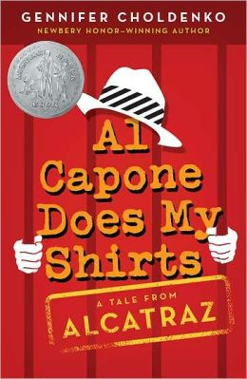
11 Birthdays: Willow Falls Series, Book 1
13 Gifts: Willow Falls Series, Book 3
A Corner of the Universe
A Long Way from Chicago: A Novel in Stories
A Swiftly Tilting Planet
A Wind in the Door
A Wrinkle in Time
A Year Down Yonder
Across Five Aprils
Al Capone Does My Shirts: Tales from Alcatraz Series, Book 1
Artemis Fowl: Artemis Fowl Series, Book 1
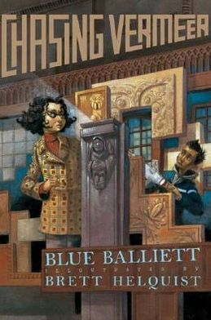
Ballet Shoes
Best Friends and Drama Queens: Allie Finkle's Rules for Girls Series, Book 3
Best of the Best: Baseball Great Series, Book 3
Blast From the Past: Allie Finkle's Rules for Girls Series, Book 6
Bomb: The Race to Build—and Steal—the World's Most Dangerous Weapon
Brian's Winter: Hatchet Series, Book 3
Brown Girl Dreaming
Catching Fire: Hunger Games Series, Book 2
Chasing Lincoln's Killer
Chasing Vermeer: Chasing Vermeer Series, Book 1
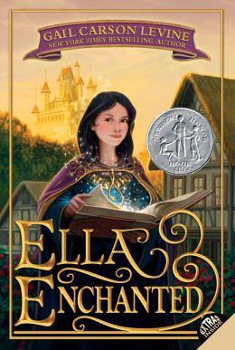
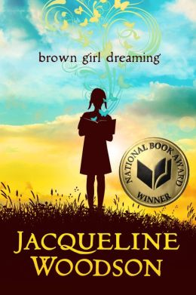
Chomp
D'Aulaires' Book of Greek Myths
Dead End in Norvelt: Norvelt Series, Book 1
Deep Zone: Football Genius Series, Book 5
Ella Enchanted
Enna Burning: Bayern Series, Book 2
Escape!: The Story of the Great Houdini
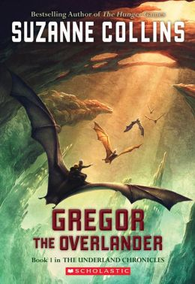
Everything on a Waffle
Fantasy League
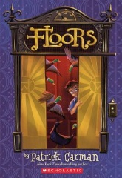
Finally: Willow Falls Series, Book 2
Floors
Forest Born: Bayern Series, Book 4
Game Changers: Game Changers Series, Book 1
Gathering Blue: The Giver Quartet, Book 2
Glitter Girls and the Great Fake Out: Allie Finkle's Rules for Girls Series, Book 5
Gregor and the Code of Claw: The Underland Chronicles, Book 5
Gregor and the Curse of the Warmbloods: The Underland Chronicles, Book 3
Gregor and the Marks of Secret: The Underland Chronicles, Book 4
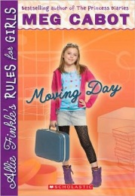
Gregor and the Prophecy of Bane: The Underland Chronicles, Book 2
Gregor the Overlander: The Underland Chronicles, Book 1
Guys Read: True Stories
Harry Potter and the Chamber of Secrets: Harry Potter Series, Book 2
Harry Potter and the Deathly Hallows: Harry Potter Series, Book 7
Harry Potter and the Goblet of Fire: Harry Potter Series, Book 4
Harry Potter and the Half-Blood Prince: Harry Potter Series, Book 6
Harry Potter and the Order of the Phoenix: Harry Potter Series, Book 5
Harry Potter and the Prisoner of Azkaban: Harry Potter Series, Book 3
Harry Potter and the Sorcerer's Stone: Harry Potter Series, Book 1
Hatchet: Hatchet Series, Book 1
Hattie Big Sky
Heavy Hitters: Game Changers Series, Book 3
Here Lies the Librarian
Hoot
Inkheart: The Inkheart Trilogy, Book 1
Jacob Have I Loved
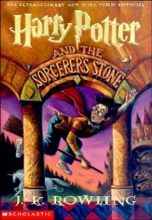
Life As We Knew It: The Last Survivors Series, Book 1
Lincoln's Grave Robbers
Little Women: Little Women Series, Book 1
Maniac Magee
Mary Poppins
Messenger: The Giver Quartet, Book 3
Millicent Min, Girl Genius
Mockingjay: Hunger Games Series, Book 3
Moon Over Manifest
More Adventures of the Great Brain: The Great Brain Series, Book 2
Moving Day: Allie Finkle's Rules for Girls Series, Book 1
Number the Stars
Okay for Now
Our Only May Amelia: May Amelia Series, Book 1
Out of the Dust
Prince Caspian: The Chronicles of Narnia, Book 4
Princess Academy: Princess Academy Series, Book 1
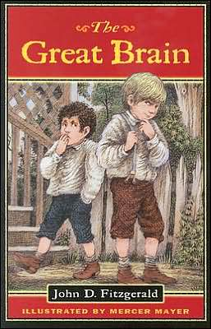
Queste: Septimus Heap Series, Book 4
Rivals: Baseball Great Series, Book 2
River Secrets: Bayern Series, Book 3
Scat
Son: The Giver Quartet, Book 4
Stage Fright: Allie Finkle's Rules for Girls Series, Book 4
Stargirl: Stargirl Series, Book 1
Syren: Septimus Heap Series, Book 5
The Alchemyst: The Secrets of the Immortal Nicholas Flamel Series, Book 1
The Arctic Incident: Artemis Fowl Series, Book 2
The Atlantis Complex: Artemis Fowl Series, Book 7
The Battle of the Labyrinth: Percy Jackson and the Olympians Series, Book 4
The Blood of Olympus: The Heroes of Olympus Series, Book 5
The Boy on the Wooden Box
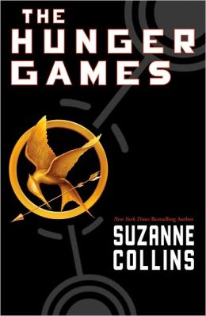
The Bronze Bow
The Emerald Atlas: The Books of Beginning Series, Book 1
The Enchantress: The Secrets of the Immortal Nicholas Flamel Series, Book 6
The Eternity Code: Artemis Fowl Series, Book 3
The Fire Chronicle: The Books of Beginning Series, Book 2
The Giver: The Giver Quartet, Book 1
The Goose Girl: Bayern Series, Book 1
The Great Brain: The Great Brain Series, Book 1
The Horse and His Boy: The Chronicles of Narnia, Book 3
The House of Hades: The Heroes of Olympus Series, Book 4
The Hunger Games: Hunger Games Series, Book 1
The Last Battle: The Chronicles of Narnia, Book 7
The Last Guardian: Artemis Fowl Series, Book 8
The Last Olympian: Percy Jackson and the Olympians Series, Book 5
The Last Present: Willow Falls Series, Book 4
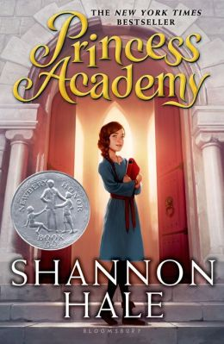
The Lightning Thief: Percy Jackson and the Olympians Series, Book 1
The Lion, the Witch and the Wardrobe: The Chronicles of Narnia, Book 2
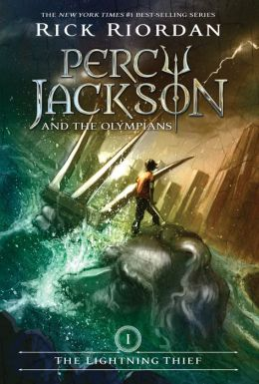
The Lost Colony: Artemis Fowl Series, Book 5
The Lost Hero: The Heroes of Olympus Series, Book 1
The Magician: The Secrets of the Immortal Nicholas Flamel Series, Book 2
The Magician's Nephew: The Chronicles of Narnia, Book 1
The Mark of Athena: The Heroes of Olympus Series, Book 3
The Necromancer: The Secrets of the Immortal Nicholas Flamel Series, Book 4
The New Girl: Allie Finkle's Rules for Girls Series, Book 2
The Notorious Benedict Arnold: A True Story of Adventure, Heroism & Treachery
The Opal Deception: Artemis Fowl Series, Book 4
The Penderwicks at Point Mouette: The Penderwicks Series, Book 3
The Penderwicks on Gardam Street: The Penderwicks Series, Book 2
The Penderwicks: The Penderwicks Series, Book 1
The River: Hatchet Series, Book 2
The Sea of Monsters: Percy Jackson and the Olympians Series, Book 2
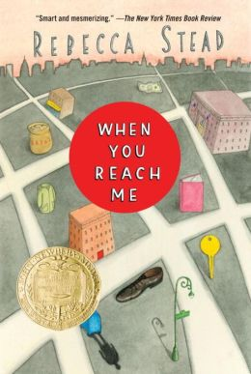
The Secret Garden
The Sign of the Beaver
The Silver Chair: The Chronicles of Narnia, Book 6
The Son of Neptune: The Heroes of Olympus Series, Book 2
The Sorceress: The Secrets of the Immortal Nicholas Flamel Series, Book 3
The Time Paradox: Artemis Fowl Series, Book 6
The Titan's Curse: Percy Jackson and the Olympians Series, Book 3
The Voyage of the Dawn Treader: The Chronicles of Narnia, Book 5
The Warlock: The Secrets of the Immortal Nicholas Flamel Series, Book 5
The Watsons Go to Birmingham - 1963
Titanic: Voices From the Disaster
War Horse: War Horse Series, Book 1
When You Reach Me

